Referred-

<https://x-engineer.org/projects/anti-lock-braking-system-abs-modeling-simulation-xcos/#:~:text=Anti-lock%20braking%20systems%20>

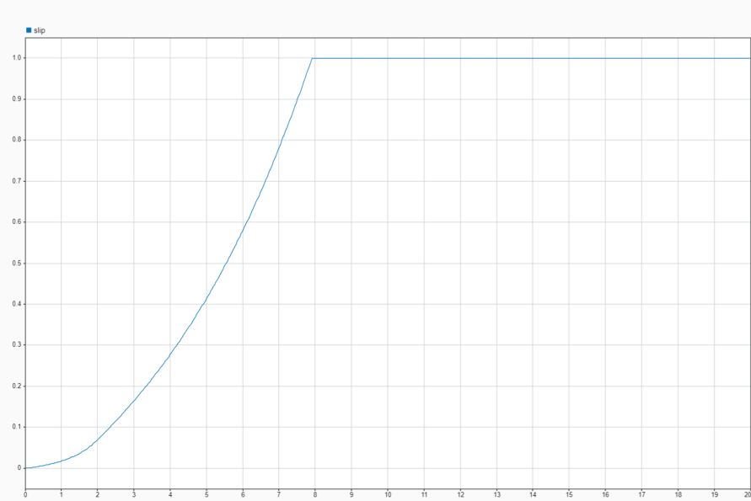

Slip without ABS

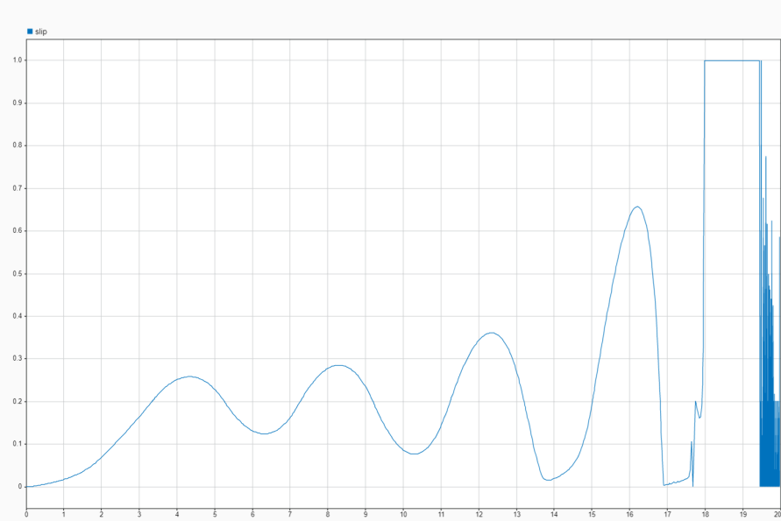

Slip with ABS

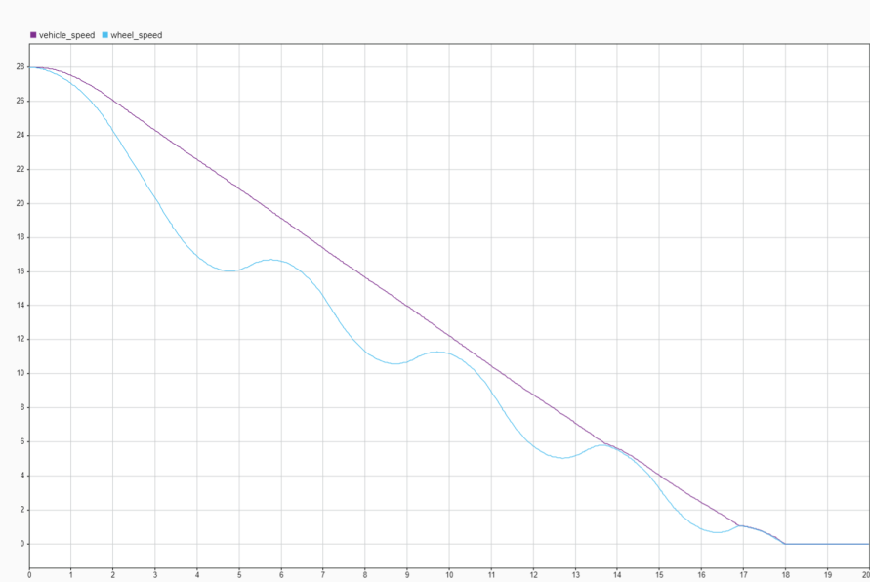

Speed with ABS

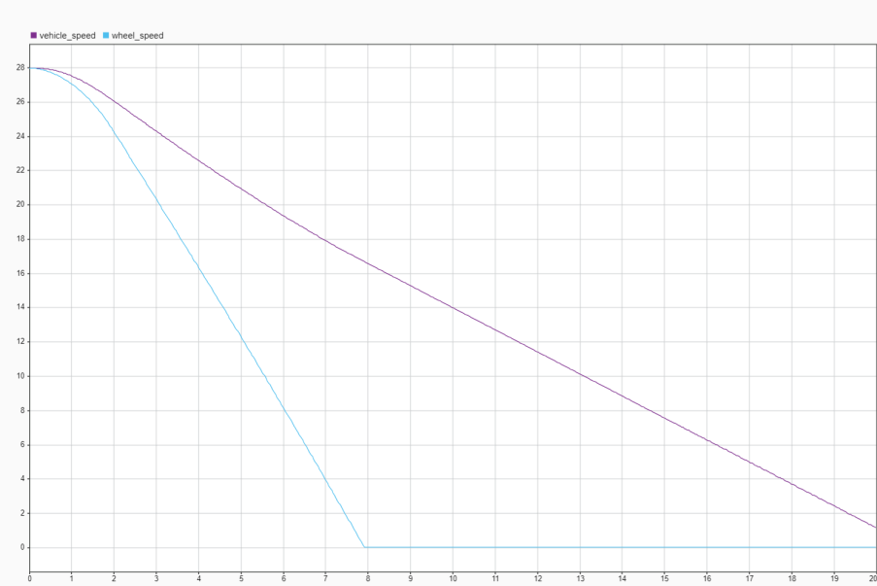

Speed without ABS